Prescribing Tobacco Cessation Products

A
CCESSING MOODLE

With your browser open type in: https://hscmoodle.health.unm.edu/ into the Address space located on your toolbar in your browser widow OR click on the link above. Direct link: https://hscmoodle.health.unm.edu/course/index.php?categoryid=9 Don’t forget to bookmark it!

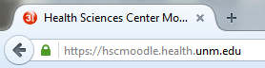

N
EW ACCOUNT USER

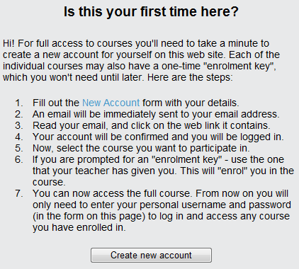
- You must create an account. On the right hand side of the page select 'create new account'.
- Fill in the required fields (wpe suggest your first initial plus last name for a username e.g. gwashington)
  - Note that first and surname (Last name) you enter is what will print on any certificates or records.
- Click “create my new account”
- The system will send you an email to confirm your account immediately. You must confirm your account to gain access.
- Click the link in the email (or copy and paste it into the address window in your browser) to confirm your account. If you do not receive a confirmation email with-in 30 minutes contact HSC-NEOTechSupport@salud.unm.edu for manual confirmation.

Don’t forget to write down your username and password

P
REVIOUS ACCOUNT USER

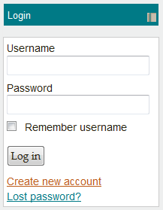
We recently moved over to a new version of Moodle. All accounts have been removed. A new one will NEED to be created even if you had a previous account in Moodle. We still have access to your account information in the old system and will retain it for up to 3 years.

If you have already created an account or we previously created one for you, please use this information to log-in. Otherwise see below for other options.
Forgotten Username or Password
You can do one of two things depending on your situation
- Active email account: Request your account information by clicking on the “Lost Password?” link. You will need to know your username and active email information.
- Inactive email account: If you are not sure what email is on your account OR it is no longer in use contact NEO directly at HSC-NEOTechSupport@salud.unm.edu to request account information. A temporary password will be assigned to you. Please update account information with current information after logging in.

U
PDATE PROFILE INFORMATION
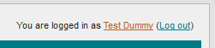
Need to update your account with new information such as email, location, username etc.? Follow the steps outlined to update your profile.
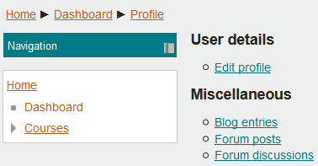
- Once logged in you can click on your account profile located at the top right corner of the screen. You will see a message that says "You are logged in as [name here]"
- Click on your name. You will then see your account info.
- Click on the Edit profile link
- Update any of the fields needed (email, location, username etc.)
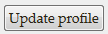
- Don't forget to save the changes by clicking on the Update Profile button located on the bottom of the screen

C
OURSE ACCESS

Now that you have logged into your account you can access the course!
- Find the Course in the course Categories as follows:
Course Categories >> College of Pharmacy >> Pharmacists >> New Mexico Pharmacists Prescriptive Authority for Tobacco Cessation Course (*Note there is a student and non-student course link)

- Enter the enrollment key ‘testgroup’ to enroll in the course

T
ECHNICAL SUPPORT

If you run into any technical problems email: HSC-NEOTechSupport@salud.unm.edu with your name, course title, phone number, and any specifics on your problem.
If you have a question about the content please email faculty at: HSC-AskNEOFaculty@salud.unm.edu

